**"Day 3 - API Integration Report - [Nike Store]"**

Aqsa Iftikhar 00001663

**Introduction**

This document provides a detailed overview of the API integration process, schema modifications, and data migration into Sanity CMS for the Nike Store. The objective was to enable seamless API interactions, integrate external product data, and populate the CMS to build an efficient and robust marketplace.

**API Integration Process**

**1. API Integration**

The API integration process was focused on retrieving external product data and populating it within Sanity CMS. Below are the key steps involved:

**1.1 Identifying API Endpoints**

The external API that provides the product data was thoroughly analyzed. The following types of endpoints were identified:

* **Product Details Endpoints**: These endpoints provide essential information such as product title, price, description, inventory levels, etc.
* **Image and Category Endpoints**: Endpoints that supply product images and category-related data.

**1.2 Creating API Fetch Functions**

To retrieve data from the identified API endpoints, custom fetch functions were created using the fetch() method. These functions allow for smooth data retrieval and ensure that the external product data is correctly transferred into the Sanity CMS.

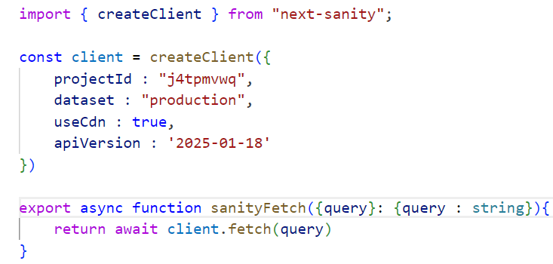**Example Code Snippet:**

**2. Adjustment made to schemas:**

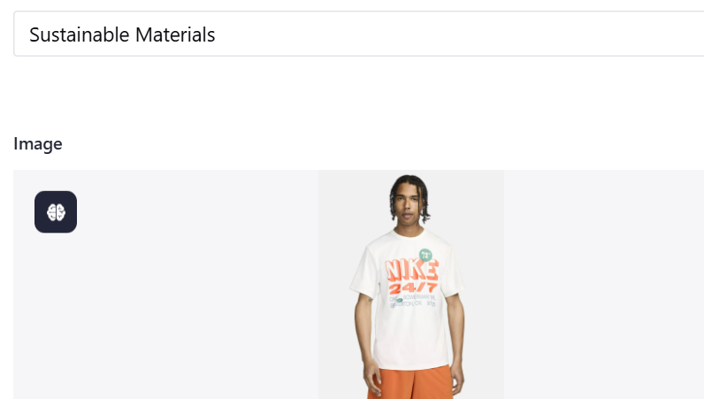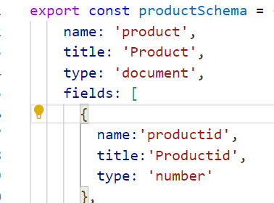 id added into schema added some images

#### 3. Data Migration

The data migration process focused on transferring product information from an external API into Sanity CMS for the Nike Store.

##### Developing the Migration Script

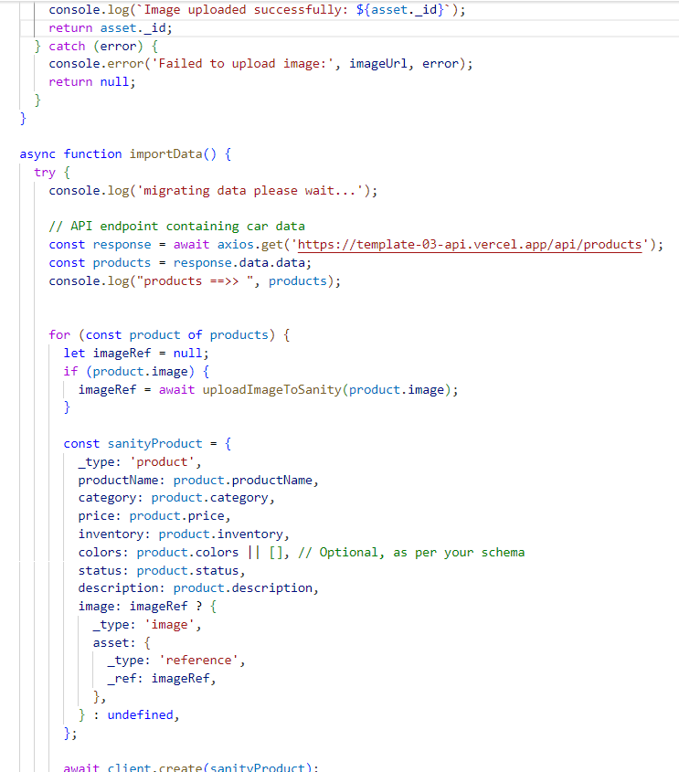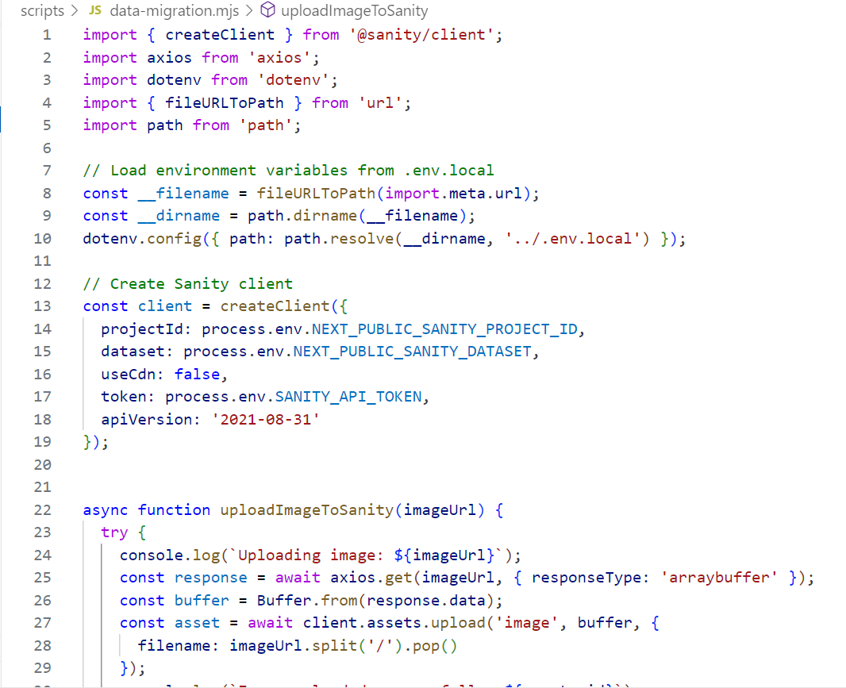A Node.js script was created to streamline and automate the migration process. The script utilized Sanity’s client library to ensure smooth and efficient handling of the product data during the migration.

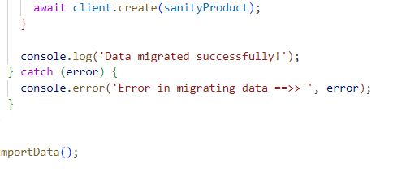

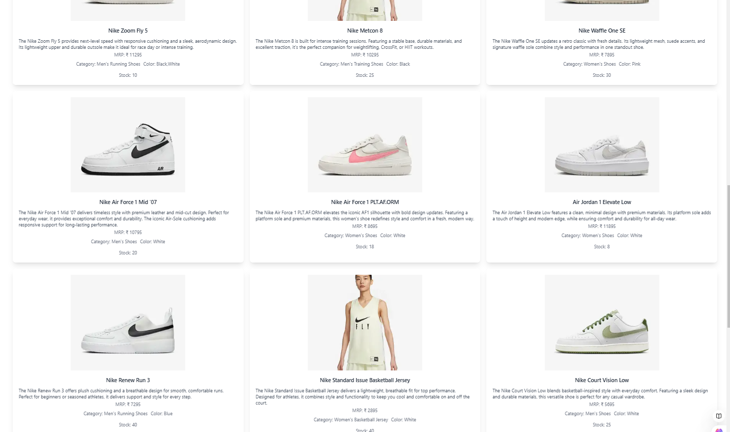**Data successfully displayed in the frontend.**

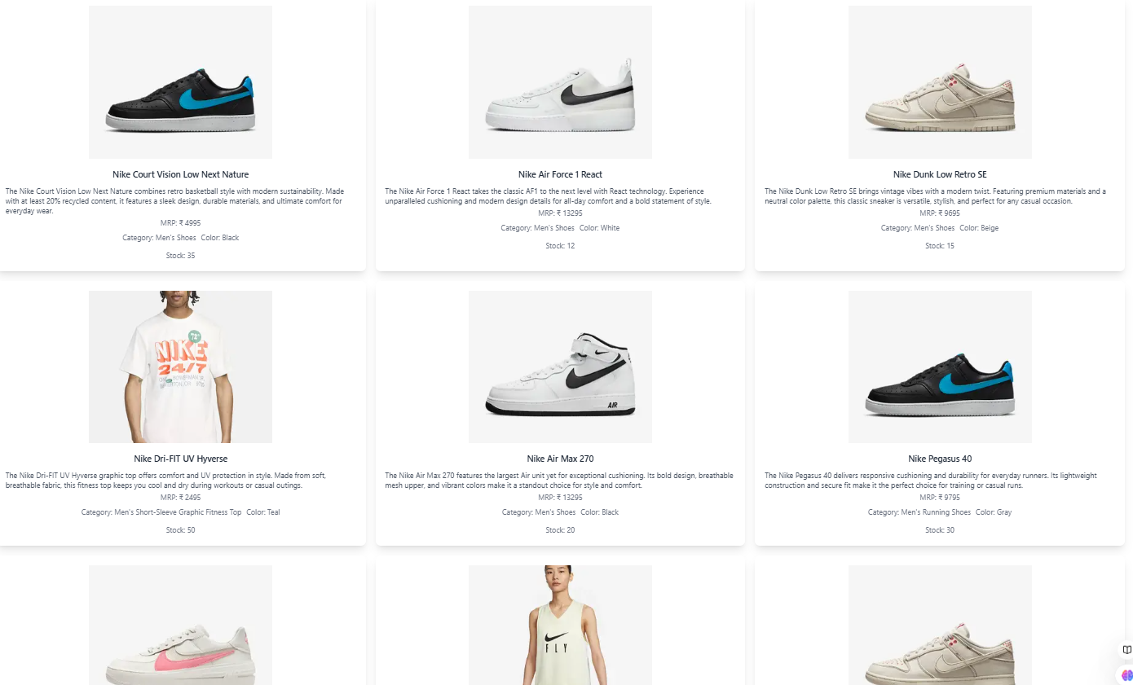

**Populated Sanity CMS fields.**

